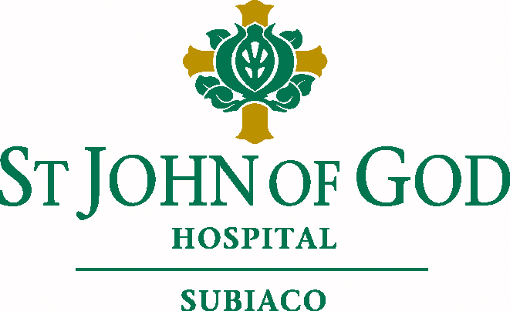
POSITION DESCRIPTION

POSITION TITLE: |  |  | Social Worker
CLASSIFICATION: |  |  | HSU Caregiver Agreement
DIVISION: |  |  | Nursing Services
DEPARTMENT: |  |  | Social Work
REPORTS TO: |  |  | Coordinator Social Work
REPORTING TO THIS POSITION: |  |  | Nil
PERFORMANCE AND DEVELOPMENT PLAN:
Conducted during the first 3 months from time of commencement then annually by immediate Supervisor/Manager. This Position Description shall be considered at the time of conducting your Performance and Development Plan.

CERTIFICATION
The details contained in this document are an accurate statement of duties, responsibilities and other requirements of the position at the time of review:
Signed: |  |  |  |  | Date:
 |  | Coordinator Clinical Leadership

REVIEWED
As occupant of the position I have noted the statement of duties, responsibilities and other requirements as detailed in this document:
Signed: |  |  |  |  | Date:
 | Caregiver
Printed:
 | Caregiver

- POSITION PURPOSE

- Provide a professional and effective Social Work Service to patients, families and their carers offering a range of support and interventions.
- Promote the service within the Hospital and undertake review and evaluation of the Social Work Service.

- POSITION DUTIES/FUNCTIONS

2.1 Mission & Values

- Capacity to understand and willingness to support and promote the Mission and Values of St John of God Health Care.

2.2 Team Work

- Attend and participate in multidisciplinary meetings, as a valued team member promoting and contributing to a supportive team environment.
- Act as a role model and resource to peers.
- Promote a team approach to problem solving and decision making.

  - Quality and Risk

- Participate in, contribute to, implement and evaluate quality improvement and risk management at St John of God Hospital Subiaco.
- Actively support the Hospital Accreditation process.
- Ensure customer grievances are fully investigated, managed and responded to appropriately and in a timely manner.

2.4 Occupational Safety & Health

- Adhere to requirements of the Occupational Safety and Health Legislation and infection control guidelines.

2.5 Environment

- The caregiver, recognising St John of God Hospital Subiaco’s public commitment to responsible environmental stewardship, will support the Environmental Action Strategy goals in their everyday duties.

2.6 Communication and interpersonal relationships

- Communicate effectively with all customers using the appropriate channels, language/terminology.
- Social Work documentation to reflect hospital standards and legal requirements.
- Utilise negotiation, mediation and conflict resolution skills to facilitate teamwork and to ensure optimal patient care.
- Facilitates professional working relationships between medical, nursing and other health care providers.

  - Planning

- Develop action plans based on psychosocial assessment of patients, including Aged Care Assessment Teams (ACAT) and discharge plans, and liaising with the patient and their family/carers.
- Demonstrate an ability to organise and prioritise allocated work load within a timely manner and within resource constraints.

  - Community Liaison

- Contribute to the collection and organisation of departmental resource information.
- Liaise and network with community resource agencies for provision of services to Hospital patients.

2.9 Clinical Practice

- Provide assistance to patients, families and carers through the provision of:
- Psychosocial assessments
- Discharge planning in conjunction with interdisciplinary team members
- Counselling and support
- Resource information
- Nursing home, Hostel and Respite accommodation
- Financial information
- General accommodation information
- Other practical assistance that may be required
- Attend and contribute to multi-disciplinary team meetings and case discussions as they occur.
- Develop action plans based on psychosocial assessment of patients
- Provide written Social Work reports to treating medical practitioners or outside agencies as required.
- Apply advanced problem solving to aspects of patient care.

2.10 Management

- Compile reports and provide information as required in a timely manner.
- Assist in the preparation of departmental operational plan and budget.
- Collect and maintain statistical information related to service delivery.

2.11 Professional Development

- Undertake continuing professional development to maintain professional standards and technical skills.
- Identify the professional development needs of self and assists colleagues to identify theirs.
- Maintain responsible participation in regular supervision.
- Actively participate in committees, projects, and other hospital activities as required.

3 POSITION RESPONSIBILITIES

3.1 Confidentiality

- Maintain confidentiality of all information in accordance with your contract of employment.

3.2 Hospital Policies and Procedures

- Understand and practice the Hospital Policies and Procedures.

3.3 Equal Employment Opportunity

- Understand and participate in promoting Equal Opportunity Legislation.

3.4 Personal Effectiveness

- Attend training sessions offered by the Hospital. Recognise the necessity to continually develop skills and acquire additional knowledge appropriate to the position.
- Dress appropriate to the expectations of the specific work area and Occupational Safety and Health requirements.

ESSENTIAL SELECTION CRITERIA

POSITION TITLE: Social Worker

1. QUALIFICATIONS

- A degree in Social Work
- Eligibility for membership of the Australian Association of Social Workers.

2. COMMUNICATION

- Excellent interpersonal and communication skills including verbal and written communication skills.
- Analytical and problem solving ability.
- Negotiation and conflict resolution skills

3. SKILLS & RELEVANT EXPERIENCE OR KNOWLEDGE

- Understanding of practice in a hospital setting incorporating knowledge of hospital structure and working environment.
- Ability to provide psychosocial assessments, identify issues, develop an intervention plan and provide ongoing review.
- Demonstrated planning and organising ability.
- Knowledge of community resources.
- Working knowledge of computer systems.
- Demonstrated team work skills.
- A willingness and capacity to embrace the mission and values of St John of God Health Care.

Desirable ( Not essential)
- Aged care experience incorporating rehabilitation and ACAT assessments

4. PHYSICAL ACTIVITIES/WORK ENVIRONMENT

- Ability to move around the Hospital site and the community as required.

5. CONDITIONS OF EMPLOYMENT

- Conditions as per the HSU Caregiver Agreement.

