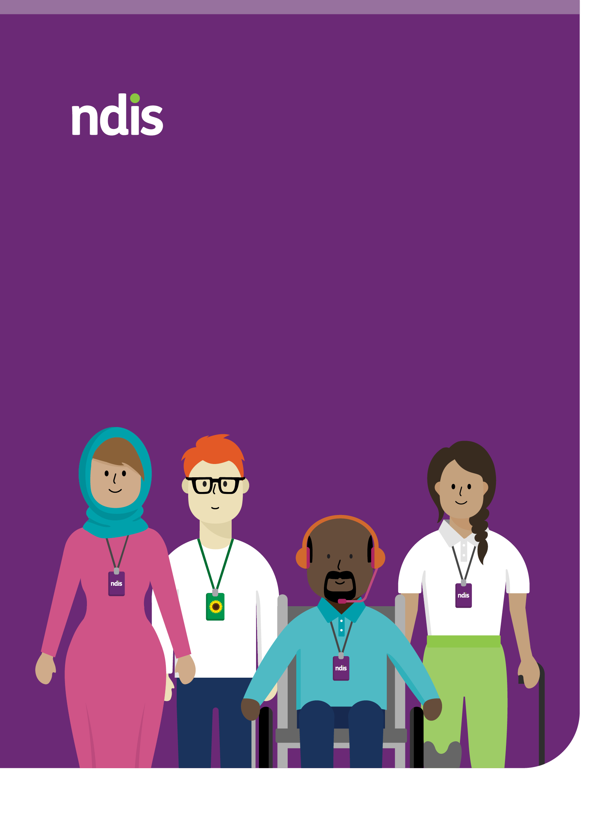
APS6 Support Needs Assessor
candidate pack

Contents

Contents 2
Acknowledgement of Country 3
Vacancy details 5
About you 6
About the role 7
Desirable skills, experience and qualifications 8
About the NDIA 9
Values 9
Benefits of working with the NDIA 10
Eligibility information 12
How to apply 13
Cracking the code 13
The Merit Principle 13
Recruitability 14
Application process 15

Acknowledgement of Country
The NDIA acknowledges the Traditional Custodians of Country throughout Australia and their continuing connection to land, sea and community. We pay our respects to them and their cultures, and to Elders past, present and emerging.
Artwork ‘Belonging’ by Charmaine Mumbulla

Welcome message
Welcome to the NDIA Support Needs Assessor candidate pack.
This pack provides you with information about the new Support Needs Assessor role at the NDIA. It will also explain our values and culture, and how you can contribute to lasting change for NDIS participants. Finally, the pack provides you with guidance on how to apply for the role.
We’re looking for candidates who are passionate about supporting people.
We want to know how you work in teams and contribute to our strong culture. We foster a culture of inclusivity, collaboration, and continuous learning, where diverse perspectives are valued and contribute directly to improving the lives of Australians with disability.
The Support Needs Assessor role is people-focused, dynamic and at the forefront of changes to planning in the NDIA. As an APS6 Support Needs Assessor, you’ll play a key participant-facing role in administering a support needs assessment tool with participants and their representatives, drawing on your professional expertise and interpersonal skills. This is a new role under New Framework Planning model, and it will be central to shaping best practice for our participants and future planning processes. You’ll contribute to validating and improving this newly established process, while supporting new team members through mentoring and coaching.
Assessments may be conducted across different settings including NDIA offices, co-located government sites, via telehealth or in participants’ local environments, offering a flexible and responsive approach to meeting participant needs.

We look forward to receiving your application and
finding out about how you can contribute to our new team.

Vacancy details

Category | Description
Job reference | 2949_10/25_EXT
Classification | APS Level 6
Salary | $96,737 - $106,950
Employment type | Full-time
Job type | Ongoing
Group | Service Delivery
Division | Scheme Transformation and Capability
Branch | Frontline Capability
Location/s | National
Clearance Level | NCHCC, NDIA Worker Screening Check and Working with Children and Vulnerable People Check
Contact officer | NDIA@dfp.com.au 1300 337 000


About you
The ideal candidate for the new Support Needs Assessor role has:
- A recognised tertiary qualification in a related health or allied health field.
- Strong communication skills, with the ability to explain complex information clearly and provide empathetic advice.
- Demonstrated ability to build trust and rapport with diverse Participants.
- Proven experience working in culturally aware, trauma-informed and ethical ways.
- Commitment to person-centred practice, putting people at the heart of decision-making.
- Ability to analyse complex information, apply relevant legislation and reflect critically on findings.
- Strong organisational skills and adaptability in changing environments.
- Confidence using ICT systems to manage information and workflows.
- Understanding of privacy and confidentiality principles when handling sensitive information.


About the role
The National Disability and Insurance Agency (NDIA) is seeking candidates to fill vacancies for Support Needs Assessors.
Duties include:
- Conducting support needs assessments by gathering information from participants and their representatives, and preparing clear, structured assessments.
- Applying established policies and procedures using sound judgement, while maintaining a participant-centred approach.
- Communicating respectfully and clearly with participants, families, representatives and support networks, including explaining assessment processes and outcomes through both virtual and face-to-face channels.
- Identifying and escalating issues based on complexity, risk or policy limitations, ensuring appropriate and timely resolution.
- Collaborating with colleagues across the NDIA to support planning and contribute to service improvements.
- Using digital tools to document decisions and manage information accurately and securely.
- Contributing to improving assessment tools, templates or processes to support consistency and quality.
- Demonstrating flexibility in delivering assessments across a range of settings, adapting methods to suit individual participant needs.
- Providing mentoring and support to new team members, contributing to a culture of learning and growth.
- Undertake semi-structured interviews as part of the assessment and information gathering process.
Please refer to the APS Work Level Standards. These have general statements about the broad requirements for each classification level.

Desirable skills, experience and qualifications
- Recognised tertiary qualification in a relevant health or allied health discipline.
- Accreditation in the I-CAN Support Needs Assessment Tool, or experience using similar evidence-based frameworks.
- Experience in planning or assessment roles within Service Delivery or Allied Health contexts.
- Lived or professional experience with disability or within the disability sector, with a strong commitment to person-centred and strengths-based approaches.
.

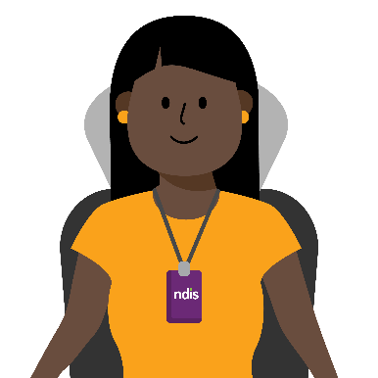
About the NDIA
The National Disability Insurance Agency (NDIA) is an independent statutory agency of the Australian Government. We are implementing the world leading National Disability Insurance Scheme (NDIS). This is one of the biggest social reforms in Australia’s history. The NDIS is designed to enhance the quality of life of, and increase economic and social participation for, people with disability.
Our Corporate Plan is the NDIA’s most significant planning document. It describes the Agency’s strategic direction and details the key activities we plan to carry out and how we will measure our performance.
Learn more about the NDIA on the NDIS website.

Values

The NDIA values are:
We value people.
We put participants at the heart of everything we do.

We grow together.
We work together to deliver quality outcomes.

We aim higher.
We are resilient and always have the courage to do better.

We take care.
We own what we do, and we do the right thing. Our values reflect our passion and commitment to building a positive, participant-centred culture.

Benefits of working with the NDIA
You can read the full benefits of our Enterprise Agreement on the Working Conditions and Benefits page on the NDIS website.

Benefit | Description
  Cutting edge innovation | The NDIA provides you with tools to enable your success. A modern, swift, and innovative ICT network. This is supported by strong collaboration with prominent international ICT vendors.
  Accessibility and inclusion at the core of what we do | Accessibility and inclusion guide our actions and decisions. By embracing diversity, we not only create a more dynamic and innovative workplace but also better serve the needs of NDIS participants.
  Design your working life | We know a workday looks different for everyone. We offer flexible work. Hybrid, flexible and part-time roles are available. We provide ergonomic assessments. The NDIA will help you create a positive work-life balance.
  Support that cares about your wellbeing | The Agency's “Well+” program provides a comprehensive range of supports for you and your family members, to promote, and maintain your mental and physical health.
  Tailored career growth | Study allowances and time off. Support to build your career. Mentorship, temporary job transfers and a specialised online learning platform. Training opportunities to develop your skills.
  Modern facilities across Australia | The NDIA is committed to creating accessible and inclusive workplaces for all staff. Office locations are available throughout Australia and the NDIA promotes flexible working. Our offices feature open plan work environments and designated spaces such as quiet zones, collaboration areas and wellness rooms.

A safe place to be your authentic self and thrive
The NDIA takes pride in actively creating a culturally safe, inclusive, accessible and caring workplace.
We are committed to employing a diverse workforce and empowering them to thrive.
Our people reflect the rich life experiences and broad identities of all Australians. Our Office of Agency Accessibility and Inclusion is here to support you at work. We have a disability action plan and other inclusion plans to help you succeed.
At the NDIA, we work to nurture and sustain a supportive, inclusive and culturally safe workplace. This celebrates and reflects the people we serve and the broader Australian community. We acknowledge and welcome everyone including people with disability, Lesbian, Gay, Bisexual, Transgender, Intersex, Queer, Asexual, Sistergirl, Brotherboy Plus (LGBTIQASB+), varying cultural and linguistic backgrounds, mature age workers and those new to the workforce. We also honour gender equality in all we do.
We are dedicated to collaborating and growing together. To do this, we leverage the vast knowledge, expertise and unique lived experiences of our team members.
By joining us, you will become a key part of a community driven by respect, support and authenticity. We engage in initiatives that are challenging and inspiring. They are shaping a fairer Australia.

Read more on our Inclusion and Diversity page.

Eligibility information
To be eligible for employment with the NDIA, you must meet certain conditions before your employment can begin. These are set out within the Public Service Act 1999. Requirements include:
- Employment Suitability Check/Police Check – This includes the ability to obtain and maintain an Australian Government security clearance if you are successful in getting a job.
- Citizenship – You must be an Australian citizen to be eligible for employment with the NDIA.
- NDIS Worker Screening Check – If applicable to the role you are successful in. This determines if a person is excluded from working in certain roles with people with disability.


How to apply
To apply, go to the job via our NDIS Careers page. Start your application by clicking the ‘begin’ button.
Your application should include:
- A current resume
- A succinct pitch (maximum 500 words) quoting job reference 2949_10/25_EXT
Your pitch is your opportunity to tell us why you are the right candidate to join the Scheme Transformation and Capability Division, why you want to work for us and what you can contribute.
Make sure to highlight relevant examples and accomplishments that show your ability to deliver. Your pitch needs to demonstrate that you have the capabilities, skills and attributes as stated in the ‘About you’ and ‘About the role’ sections. You can use the APS6 Work Level Standards to ensure you pitch at the right level.
If you need adjustments including alternate formats or assistance to take part in the recruitment process, please let us know. You can do so either when you fill out the application form or email ndia@dfp.com.au or call 1300 138 337.

Cracking the code
We encourage you to look at the Cracking the code | Australian Public Service Commission website to help write your application.

The Merit Principle
The NDIA uses a range of selection tools to assist us in the hiring process. We uphold the APS Merit Principle. Our selection processes are designed to find the best available person for the job.

Recruitability
Diverse skills, perspectives and abilities are appreciated. They are valued and crucial to our workplace culture.
The NDIA is committed to supporting the employment and career development of people with disability.

RecruitAbility applies to this vacancy
Under the RecruitAbility scheme, you will be invited to take part in further assessment activities for the vacancy if you choose to opt-in to the scheme. To do so, you must declare you have a disability. You must still meet the minimum requirements for the vacancy. All requests for adjustments will be considered and managed in consultation with you.
To find out more, visit the APSC website.
In the NDIA, we believe building a culture of inclusion begins with a fair application process. If you have any questions, require support or reasonable adjustments, we are here to help. The Agency’s contact person in the Vacancy Details section of this Candidate Pack can provide confidential assistance. You need only ask.

Application process
Table 2. High level application process
Step | Details
1. Apply | Submit your application through the NDIS website.
2. Shortlist | Shortlisting is based on how well your resume and pitch demonstrate your skills for the vacancy.
3. Assessment | Shortlisted applicants may be invited to an interview with a panel. Any additional assessments will be discussed with you if required.
4. Reference check | We may contact your referees to further assess your suitability.
5. Outcome | The recruitment panel will finalise the outcome. All applicants will be notified of their result.
6. Merit pool | A merit pool may be established for 18 months and may be used to fill future vacancies.

